DDL Commands with Constraints – PRIMARY, FOREIGN KEY, UNIQUE, CHECK


Query:
alter table students add primary key(regno);
Output:
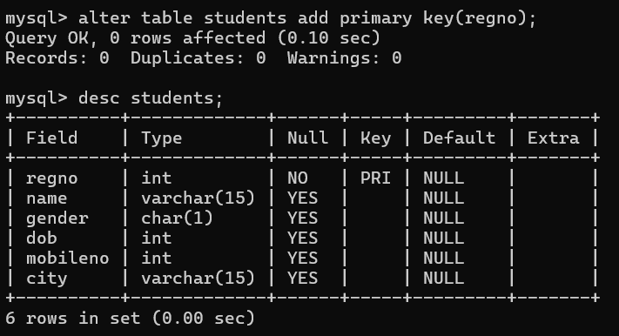


Query:
alter table faculty add primary key(facno);
alter table faculty add check(gender='M'or'F');
Output:

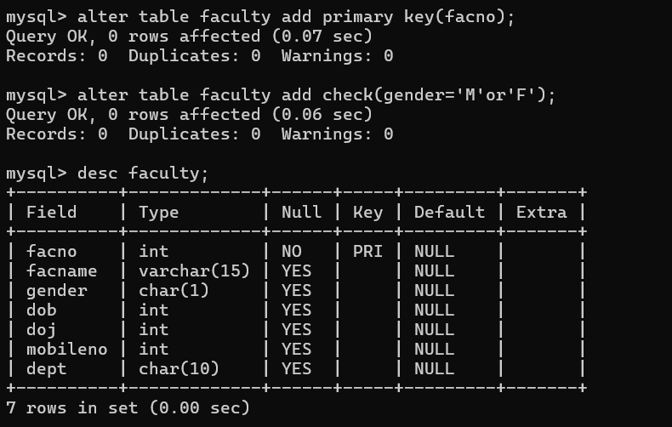


Query:

alter table department add primary key(deptno);
desc department;

Output:

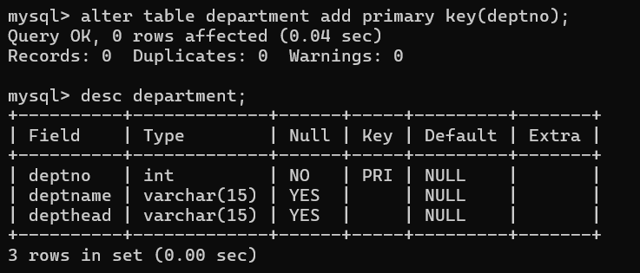



Query:

alter table course add primary key(courseno);
alter table course add check(semno>=1&&semno<=6);
desc course;

Output:

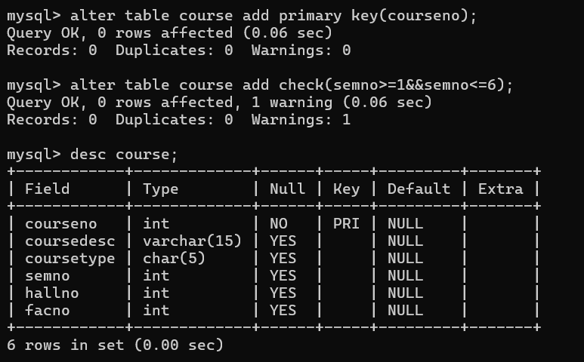


Query:

alter table students add unique key(name);
desc students;

Output:

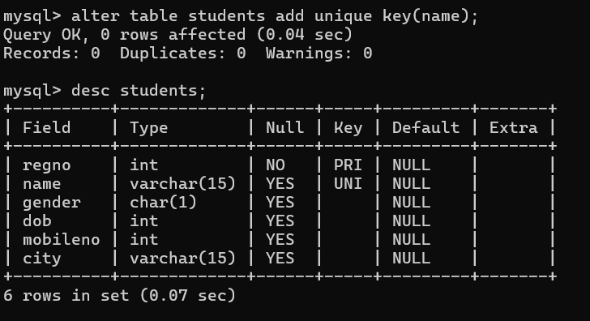

6) After the STUDENT2 & STUDENT3 tables are successfully created, test if you can add a constraint FOREIGN KEY to the RegNo of this table.

Query:

alter table students modify address int not null;
desc students;

Output:

